**A PROJECT REPORT**

**ON**

**“DIWALI SALES”**



**BY**

**SAMIKSHA DUBEY**

**ABSTRACT**

This comprehensive data analysis report thoroughly examines the Diwali sales performance of Company, shedding light on sales trends, product categories, regional disparities, and the efficacy of marketing strategies during the festive season. Leveraging extensive data analysis techniques, the report uncovers pivotal insights crucial for optimizing future Diwali sales strategies. Key findings encompass fluctuations in sales patterns, popular product categories, geographical variations, and the impact of marketing initiatives. Based on these findings, actionable recommendations are provided to enhance sales performance and capitalize on opportunities for growth in subsequent Diwali seasons. By delving deep into the intricacies of Diwali sales data, this report serves as a valuable resource for the Company to refine its strategies, cater to consumer preferences, and bolster its competitive edge in the market.

Pandas and Python play crucial roles in facilitating robust data analysis, particularly in the context of Diwali sales performance for the Company. Pandas, a powerful Python library, provides a plethora of tools for data manipulation, cleaning, and transformation.

**CONTENT**

1. Introduction

1.1. Problem Statement

1.2. Scope And Objectives

2. Literature Review

3. Basic Concepts/Technology Used

3.1.Python

4. System Requirements

5. Implementation

6. Conclusion

**Chapter 1**

**Introduction**

Diwali, the festival of lights, marks a significant period for businesses in India, with increased consumer spending driving up sales across various sectors. This report examines the Diwali sales data of Company to understand patterns, trends, and consumer behaviour during this festive period.

* 1. **Problem Statement**

Diwali, a critical period for Company, demands a deep dive into sales data to unearth trends and challenges. Key objectives include deciphering sales patterns, identifying lucrative product categories, understanding regional disparities, evaluating marketing impact, and discerning customer behavior. The core challenge lies in extracting actionable insights from complex datasets to refine future Diwali sales strategies. The aim is to optimize marketing campaigns, tailor product assortments, and leverage consumer preferences effectively. By addressing these challenges, [Company Name] can elevate its Diwali sales performance, maximize revenue, and fortify its position in the competitive market landscape.

* 1. **Scope and Objective**

The primary objective of the analysis is to derive actionable insights that can inform and optimize future Diwali sales strategies for the Company. The analysis encompasses a comprehensive examination of Diwali sales data for the Company, spanning a defined timeframe surrounding the festival. It includes-

* Identify Sales Trends
* Enhance Marketing Strategies
* Optimize Product Offerings
* Target Regional Opportunities
* Marketing Effectiveness
* Personalize Customer Engagement

**Chapter-2**

**Literature Review**

The literature review of Diwali sales trends underscores the significance of understanding consumer behaviour, regional variations, marketing strategies, and economic factors during the festive season. Studies consistently highlight a substantial increase in consumer spending across various product categories during Diwali, with seasonal demand fluctuations observed for specific items like sweets, fireworks, and gold jewellery. Regional variations in spending habits emphasize the importance of localized marketing approaches tailored to diverse preferences. Effective marketing strategies, including digital campaigns and festive discounts, play a pivotal role in driving sales during Diwali. Economic indicators such as consumer confidence and income levels also influence purchasing behaviour, highlighting the need for businesses to adapt to changing economic conditions. Additionally, customer segmentation enables businesses to tailor offerings and promotions to different demographic segments effectively. The rise of online retail further underscores the need for businesses to embrace e-commerce channels to capitalize on the growing trend of online shopping during Diwali.

**Chapter-3**

**Basic Concept/Technology Used**

In the analysis of Diwali sales data, various technologies are the dataset.

**1. Python:** Python is a versatile programming language commonly used for data analysis due to its extensive libraries such as Pandas, NumPy, and SciPy. Python provides robust tools for data manipulation, statistical analysis, and machine learning.

1. Pandas

2. Numpy

3. Matplotlib

4. Seaborn

**1. Pandas:** Pandas is a powerful Python library for data manipulation and analysis, particularly suited for working with structured data. It offers data structures like DataFrame and Series, which enable efficient handling and processing of large datasets.

**2.NumPy:** NumPy is a fundamental library for numerical computing in Python. It provides support for arrays, matrices, and mathematical functions, making it essential for performing numerical operations on large datasets.

**3.Matplotlib:** Matplotlib is a Python library for creating static, animated, and interactive visualizations. It offers a wide range of plot types and customization options, enabling users to create high-quality plots for data analysis and presentation. Matplotlib seamlessly integrates with Pandas for easy plotting of data stored in DataFrame objects.

**4. Seaborn:** Seaborn is a Python data visualization library built on top of Matplotlib. It provides a high-level interface for creating attractive and informative statistical graphics. Seaborn simplifies the process of creating complex visualizations by offering easy-to-use functions for common plotting tasks such as scatter plots, histograms, box plots, and heatmaps. Additionally, Seaborn integrates well with Pandas DataFrames and offers support for advanced statistical techniques.

# Chapter 4

**System Requirements**

Jupyter Notebook Version

Version 5.7.8 is used in our Project.

The Jupyter Notebook is a tool which we can use for our machine-learning project and statistical analysis. We can download Anaconda from the web source and within it Jupyter Notebook most useful tool for machine learning purposes.

Python Version

Python 3.11.5 is used for this project. Python is a very useful programming language. It is object-oriented and interpreted. It is a high-level language. There are lots of in-built libraries in Python which we can use easily.

Windows Version

Jupyter Notebook and python3 can be used in all operating systems including Windows, iOS & Linux. It can be run on Windows XP, Vista,8,10 &latest version of Windows 11 as well.

**Chapter 5**

**Implementation**

Implementation is the process of converting the designed system architecture into working modules where it is made sure that all the functional and non-functional requirements are met.

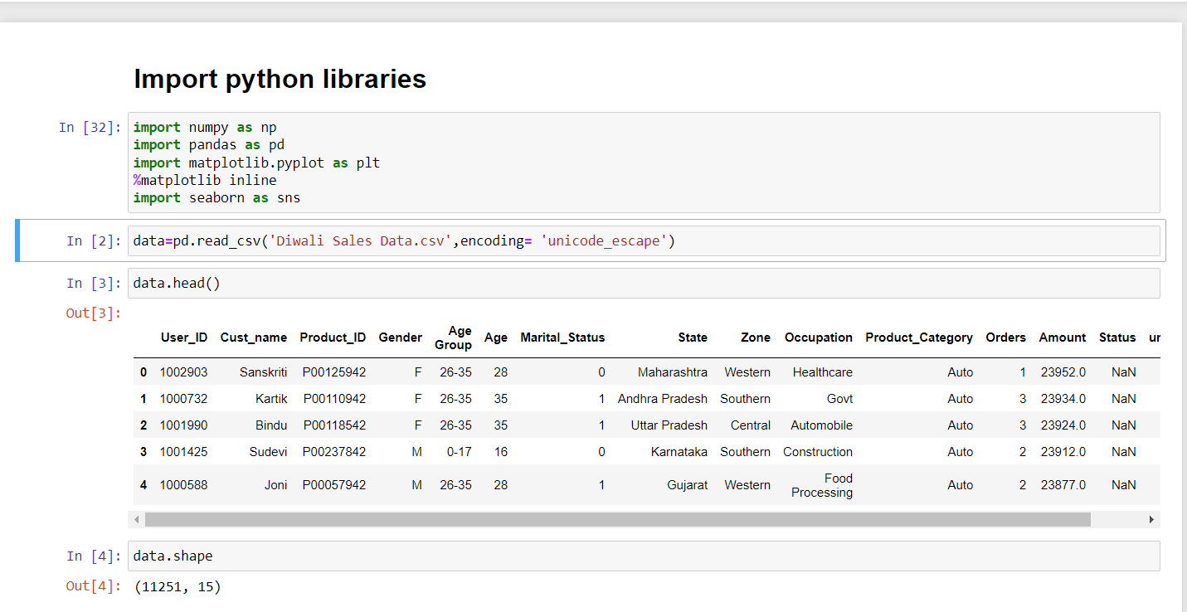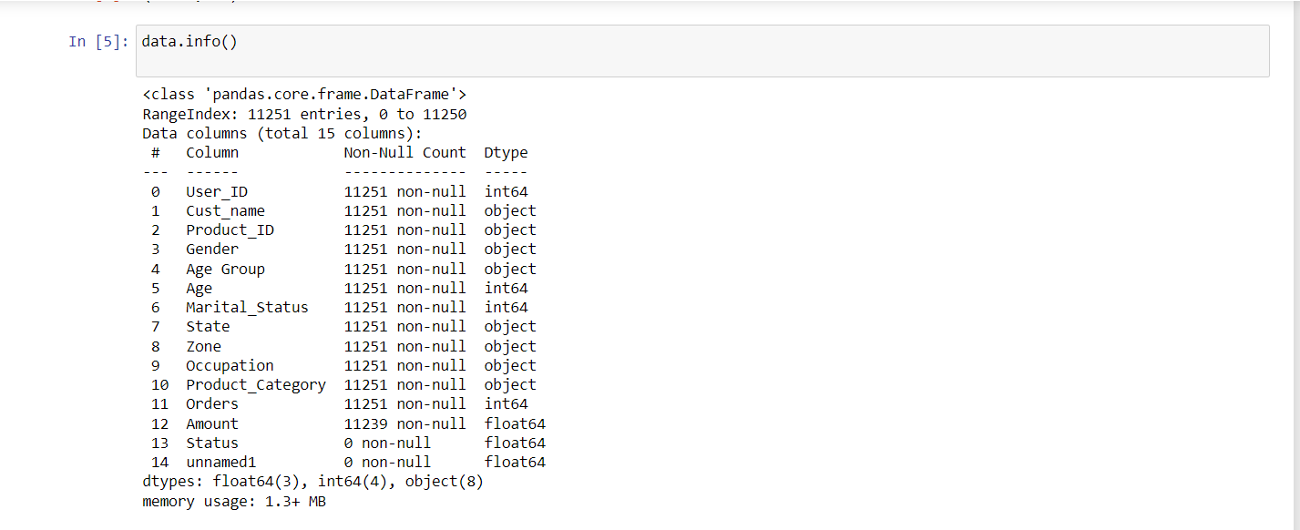

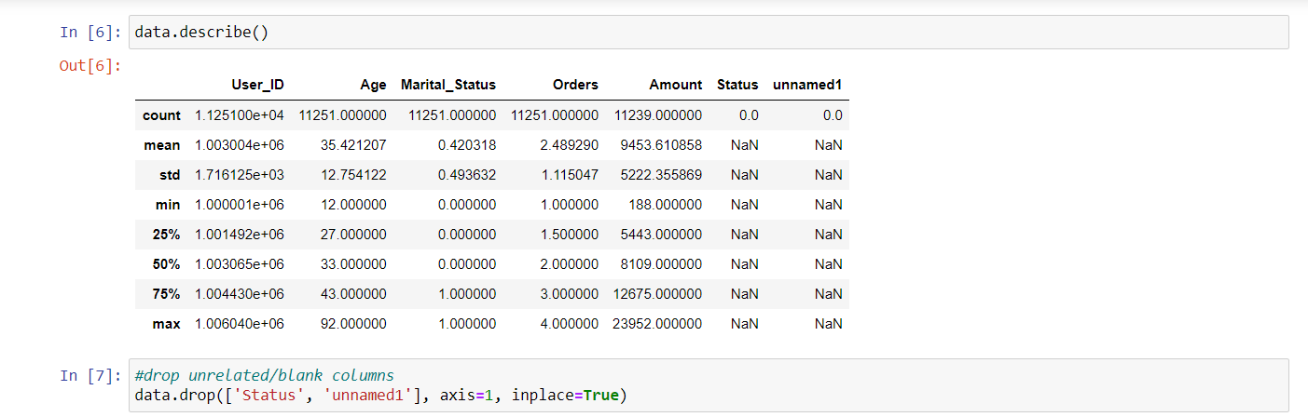

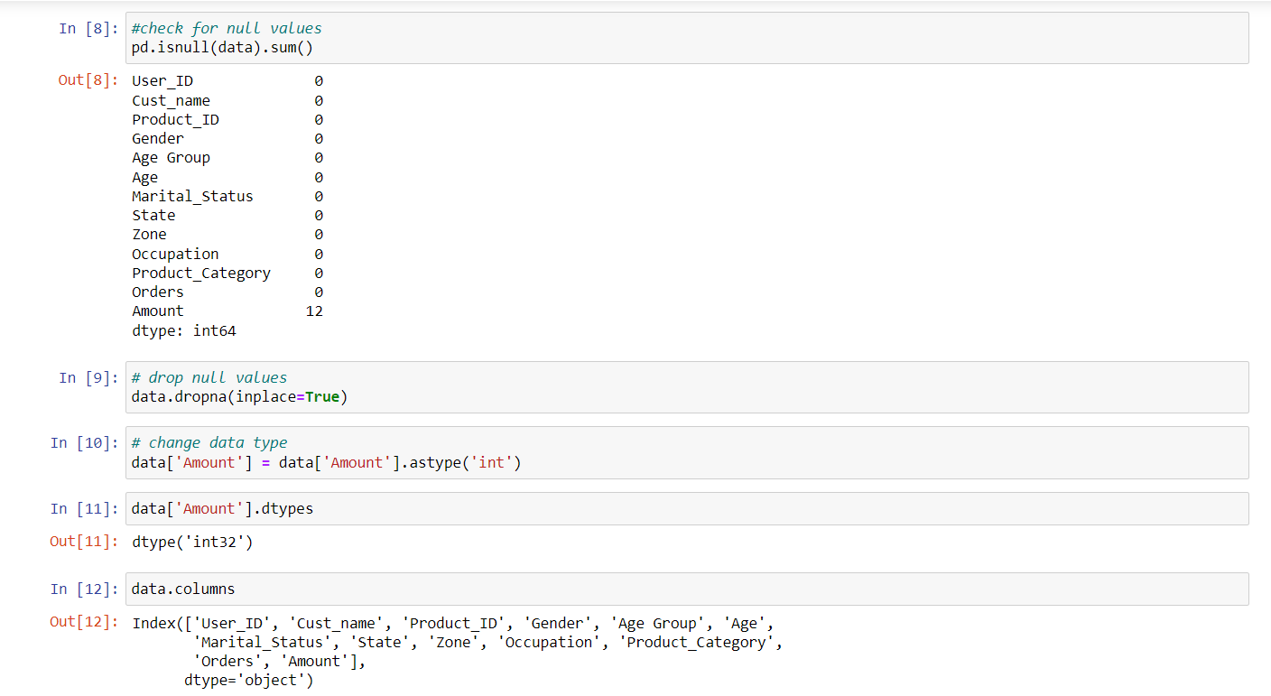

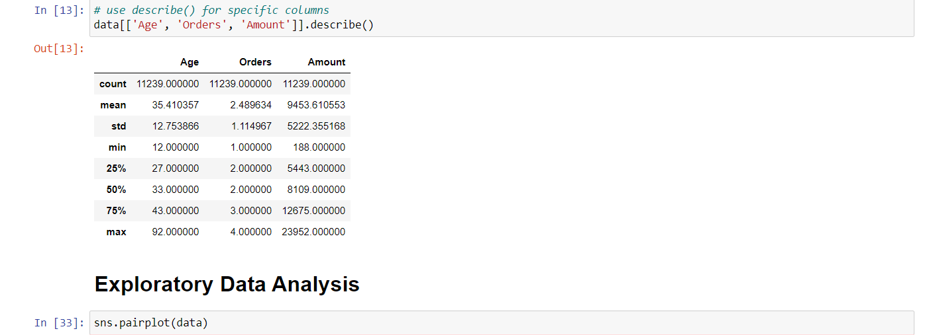

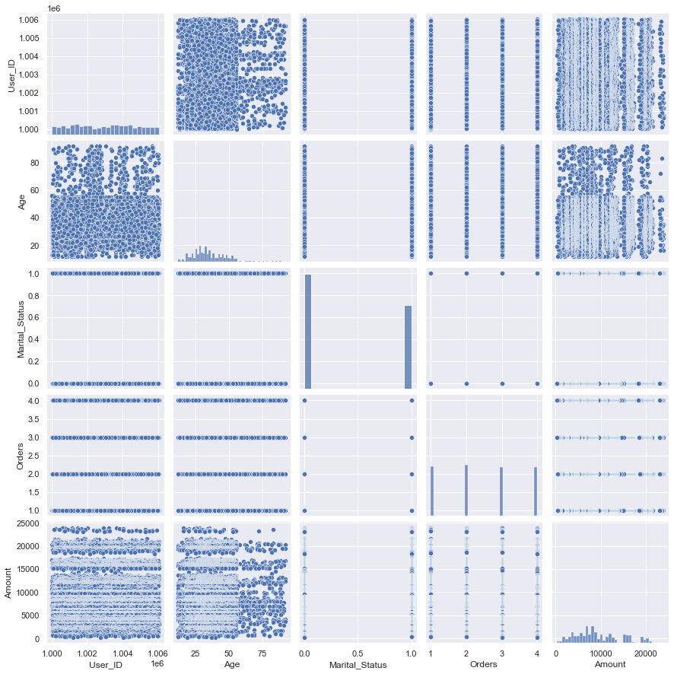

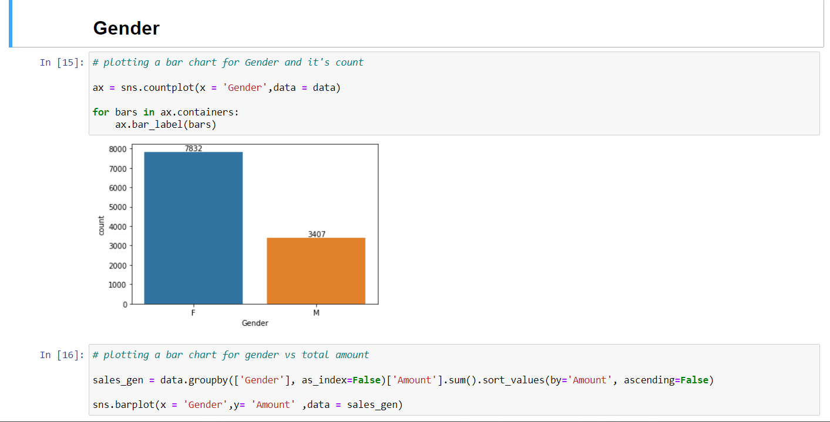

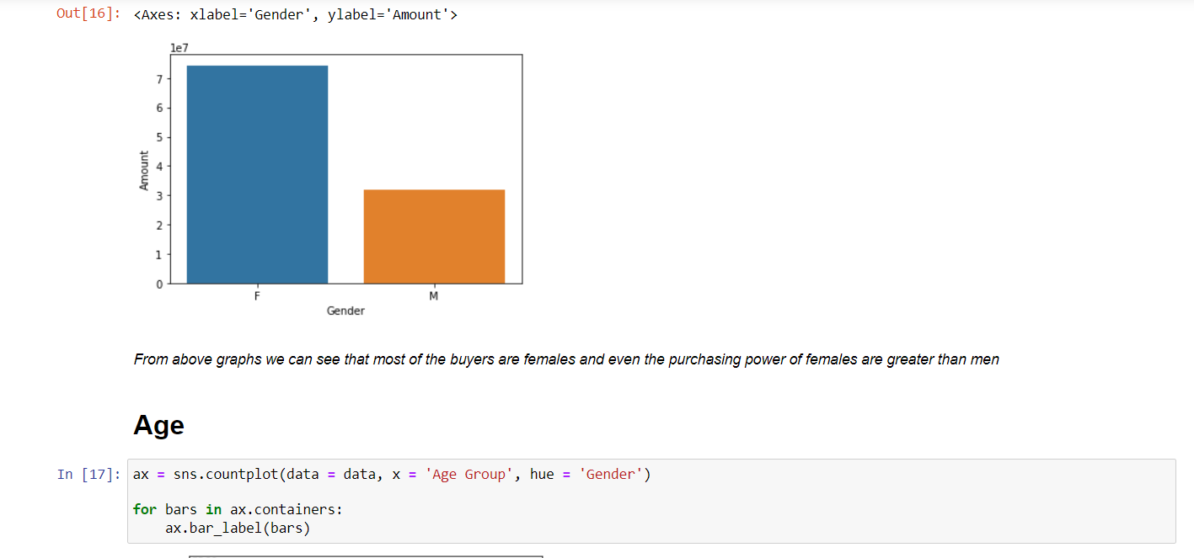

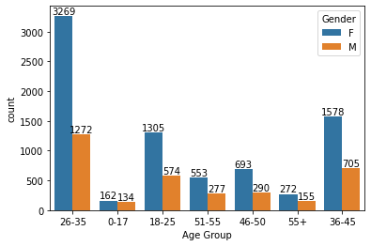

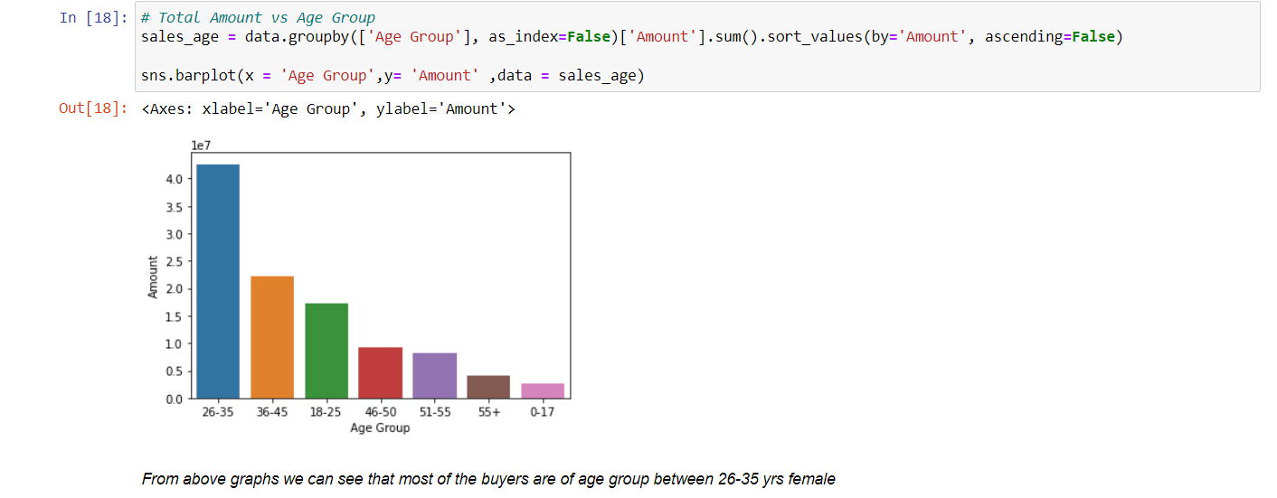

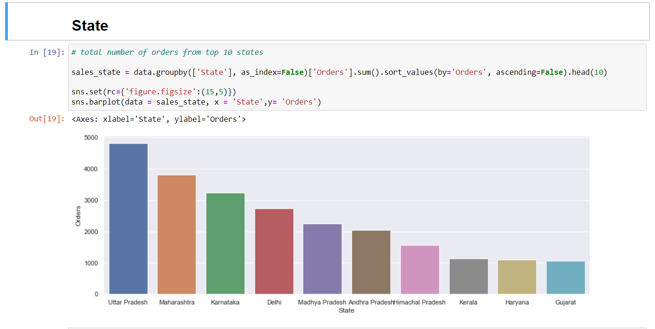

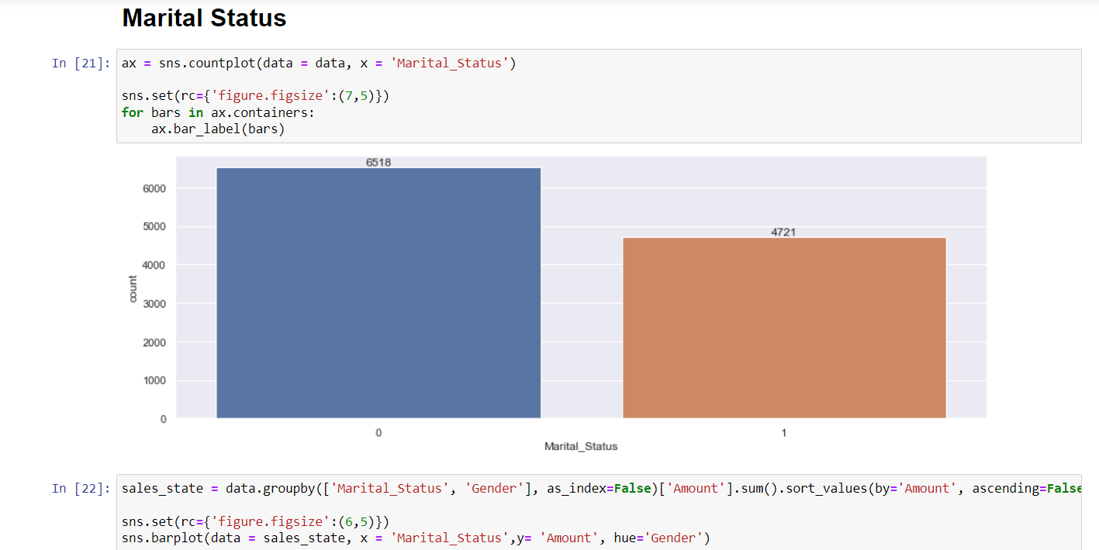

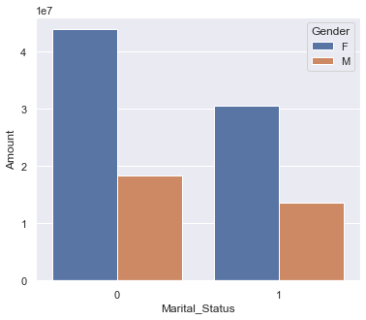

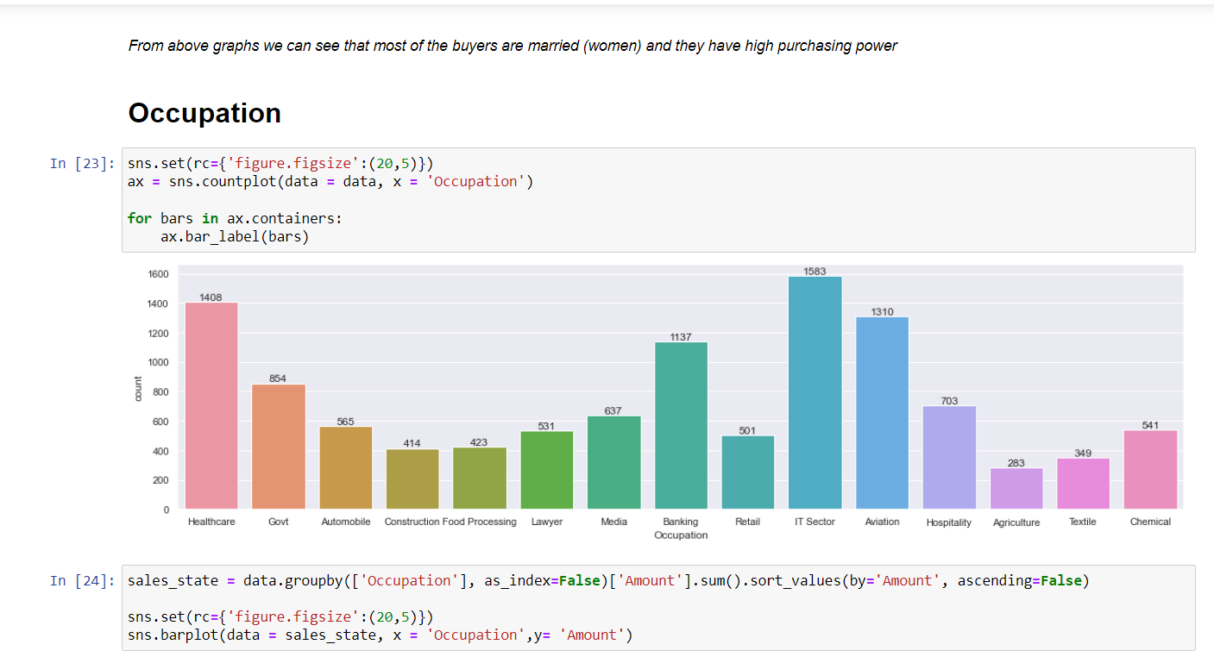

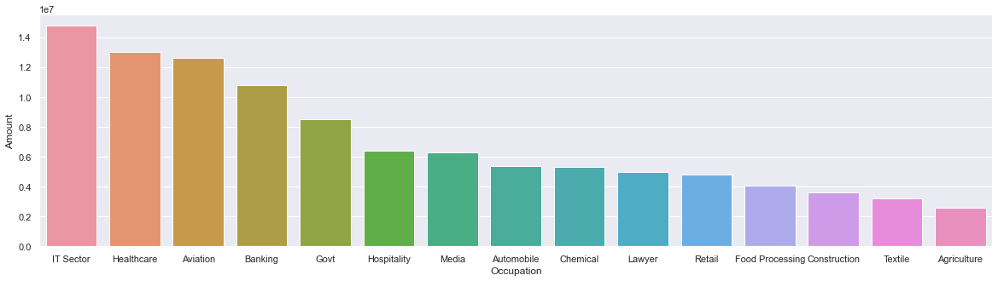

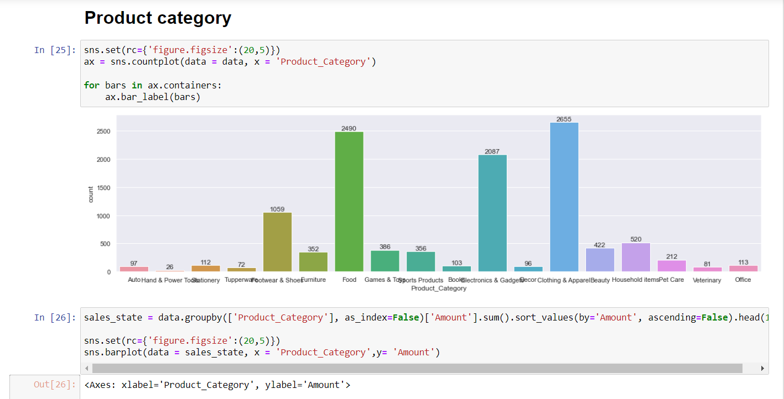

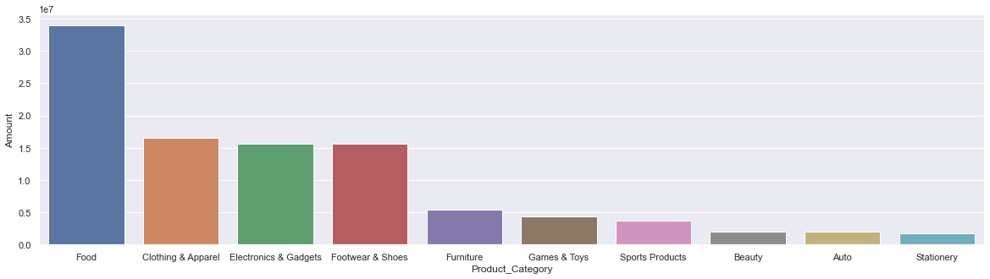

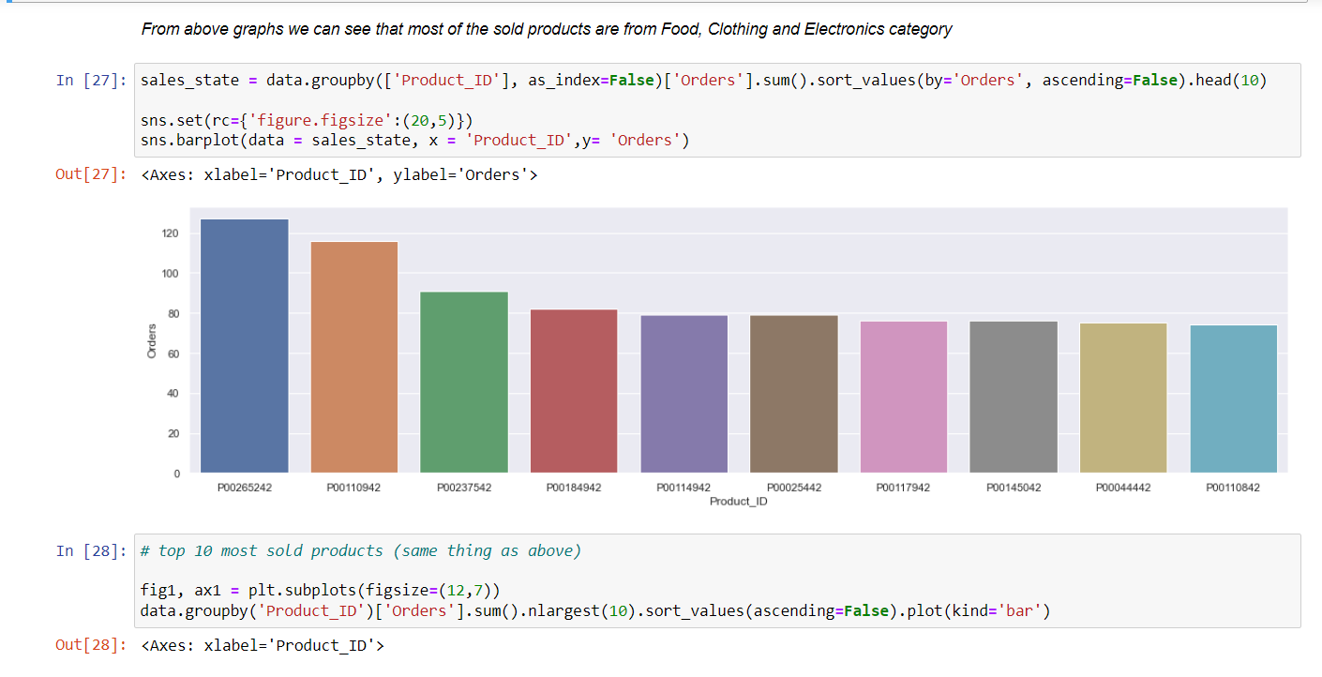

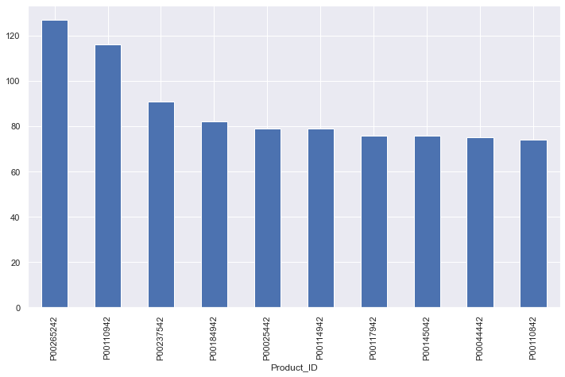

**Chapter 6**

**Conclusion**

**Important Insights:-**

* Females are participating and are more interested in Diwali sales than men. Also, the purchasing power of Females is higher than males as the total sales revenue generated from females is much higher than that of males.
* Most of the customers fall in the age group of 26-35. Customers from the age group of 26-35 are generating more than 40% of total Revenue
* The age group of 30 and around 30 are purchasing more than the rest of consumers. Old age people are the least active buyers.
* The top 5 states of India with the highest sales are Uttar Pradesh, Maharashtra, Karnataka, Delhi and Madhya Pradesh.
* we can see that the most of sales are coming from Unmarried and among them, unmarried females are the customers with the highest spending.
* The IT Sector generates the highest sales revenue and after that Aviation, Healthcare then Banking and so on.
* We can see a little deflection in data for the product category. For clothing and apparel, the number of orders is the highest but for revenue generation Food is the highest contributor.

**Conclusion:-** Married women age group 26-35 yrs from IP, Maharastra and Karnataka working in IT, Healthcare and Aviation are more likely to buy products from Food, Clothing and Electronic categories.